**SURF Meeting Minutes**

**Time and Date:** 10:00 – 10:10 Monday, 09 November 2021

**Venue: Office**

**Members:** Yue Li (YL), Xingbo Wei (XW)

# Preparations

1. Function of import TXT file into questionnaire toolkit.
   1. The TXT file format:
      1. 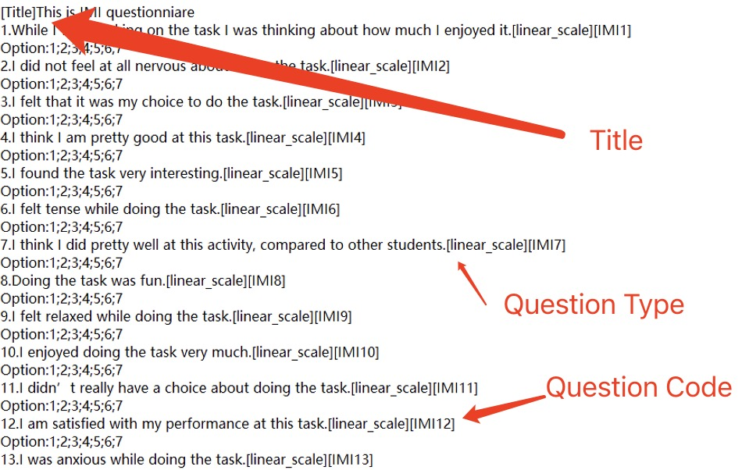
   2. The effects:
      1. 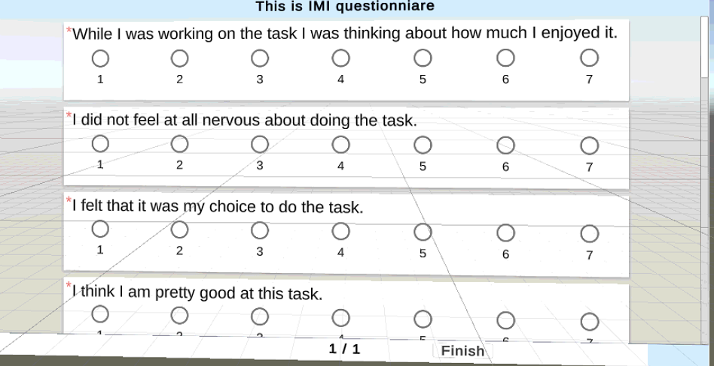
2. Interaction methods;
   1. Precious:
      1. using cone-casting in Immersive virtual environments for out of reach object Selection. Casted from users’ hand. While pointing, users can make the cone aperture wider or smaller, and change the cone’s reach. Objects that fall inside the cone will be selected.
   2. Summoning Selection:
      1. a ray is generated starting from the palm, The ray snaps to nearby objects and curl the fingers to pull the objects towards her.
3. Paper reading:
   1. ﻿The Dream is Collapsing: The Experience of Exiting VR
      1. Question: Do users become self-conscious of their actions upon exit? Are users nervous of their surroundings?
      2. Result: Author think changes to VR (both within the virtual and the real environments) that may both heighten and lessen the experience of exiting VR and speculated as to the experience of these.
      3. Method: After users experience VR, interview them and ask about the situation.

# Discussions

**Xingbo**

* XW just finished the linear-scale question style into toolkit. YL asked XW finish others style into toolkit like check box…
* YL think WX should test the questionnaire toolkit in VR device and check the storage capabilities is fine.

# Actions

1. Let the toolkit can import various of question format.
2. Testing the toolkit whether the toolkit and storage capabilities can running correctly.
3. Paper reading.
4. Learning interaction ways from YL provides website.

# Next meeting

9:30 – 10:30am, Monday, 15 Nov 2021

**V7.0**

Minutes taker: Xingbo Wei

Date: 9 November 2021

## For approval

Yue Li